Financial Data Mining

1. A table indicating how much money you would have at the end of each year by following strategy 1 and strategy 2.

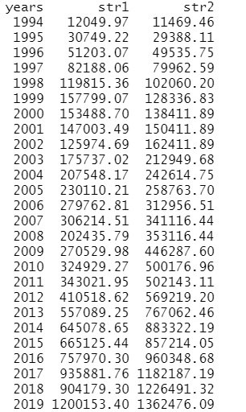

1. A plot indicating the returns of both strategies over the 26 year period.

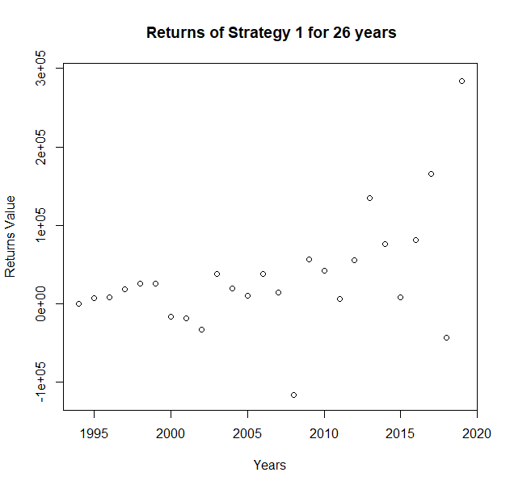

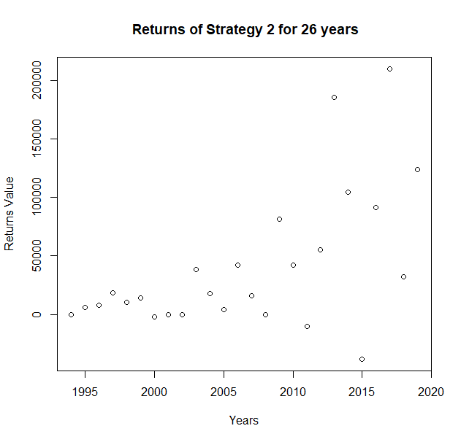

Plot with both strategies:

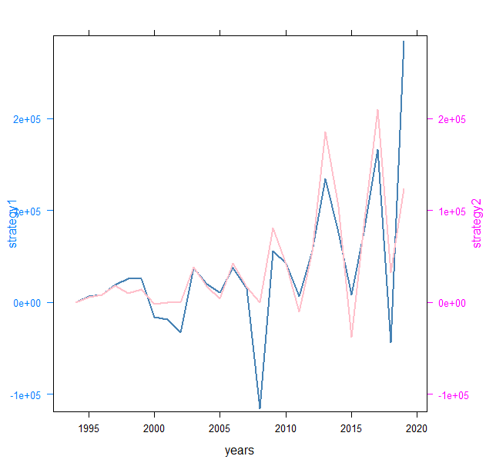

1. The total money accumulated at the end of 26 years using the different strategies.

Strategy 1 Total money at 2020-03-31 :



Strategy 2 Total money at 2020-03-31):



1. One paragraph explanation of which strategy is the best and if the results surprised you.

From the Analysis it is evident that in the initial period the strategy 1 had more profit than the strategy 2 for upto 7 years but after that strategy 2 had more profits. In strategy 2 we will invest only when the value of close price of stock is greater than the sma. So everytime when closing price goes below the sma the stocks are sold and saved in the savings account. So Depending on the rate of increase or rate of decrease of stock price we are investing on the stocks. But in Strategy 1 we are investing irrespective of the rate of decrease or rate of increase. So strategy 1 will be risky in long term investment because if the stock crashes and goes very low we will lose large amount of money. But with strategy 2 when the stock begins to crash we will be able to identify it by using the technical indicators so immeadiately we will be selling it and hence we will not be losing very large amount of money. So I think strategy 2 is the best. Yes I was surprised by the results since after 26 years the small amount of money invested each month has added up to a very large amount of money.